Palm Springs Unified School District
Transportation
Safety Plan

150 District Center Drive
Palm Springs, CA 92264
(760) 325-8774
Revised July 2021

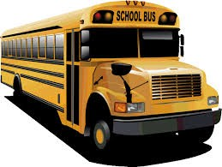

Mission Statement
It is the mission of the Palm Springs Unified School District Transportation Department to support academic achievement of our students by providing for the safe operation of a school transportation service. We believe that pupil transportation enhances the educational opportunities for all of our students. We are also dedicated to providing courteous and professional service to our students and maintain a professional behavior while operating school buses on the road. Students are our priority. The safety of our students is our primary concern.

TABLE OF CONTENTS
GENERAL PROCEDURES OF THE SCHOOL BUS 3
SCHOOL BUS SAFETY GUIDE 4
SCHOOL BUS DANGER ZONES 5
PROCEDURES FOR BOARDING THE SCHOOL BUS 6
PROCEDURES FOR UNLOADING THE SCHOOL BUS 6
CONDUCT AT A SCHOOL BUS LOADING ZONE 7
PROCEDURES FOR EXITING SCHOOL BUS 7
BUS SEATING ASSIGNMENTS 8
BUS STOP CHANGES 8
WALKING TO AND FROM A SCHOOL BUS STOP 8
RULES & REGULATIONS 9
UNAUTHORIZED ENTRY 10
AUDIO VIDEO CAMERA SURVEILLANCE 10
PROCEDURE FOR DISCONTINUANCE OF SERVICE DUE TO REDUCED VISABILITY 10
EMERGENCY EQUIPMENT 11
INCIDENTS & COLLISIONS ON A SCHOOL BUS 11
REPORTING BUS INCIDENTS & COLLISIONS 11
BUS SAFETY & EVACUATION INSTRUCTION 11
PASSENGER RESTRAINT SYSTEMS 12
SCHOOL BUS SAFETY LAW SB 1072 12
SCHOOL BUS SAFETY VIOLATION NOTIFICATION 12
DUE PROCESS 13
MECHANICAL BREAKDOWNS 14
DISCIPLINE PROCESS 14
LOADING ACTIVITY/FIELD TRIPS AT A SCHOOL SITE 14
LOADING/UNLOADING AT THE ACTIVITY DESTINATION SITE 15
ADDITIONAL SAFETY RULES FOR ACTIVITY FIELD TRIPS 15
TEACHER/CHAPERONES RESPONSIBILITIES ABOARD BUS 15
REQUIRED VEHICLE INFORMATION ON ACTIVITY/FIELD TRIPS 16
SPECIAL EDUCATION TRANSPORTATION GUIDELINE 17
WHAT SPECIAL NEEDS EQUIPMENT MIGHT BE TRANSPORTED ON A SCHOOL BUS? 17
MEDICAL/HEALTH ISSUES 17
SAFE TRANSPORTATION OF STUDENTS IN WHEELCHAIRS OR OTHER MOBILITY ASSISTANCE DEVICES 17
SPECIAL EQUIPMENT USE AND OPERATION 18
ADDITIONAL INSTRUCTIONS FOR SPECIAL NEEDS STUDENTS 19

PALM SPRINGS UNIFIED SCHOOL DISTRICT

TRANSPORTATION SAFETY PLAN
Education Code 39831.3. (a) The county superintendent of schools, the superintendent of a school district, or the owner or operator of a private school that provides transportation to or from a school or school activity shall prepare a transportation safety plan containing procedures for school personnel to follow to ensure the safe transport of pupils. The plan shall be revised as required. The plan shall address all of the following:

- Determining if pupils require escort pursuant to paragraph (3) of subdivision (c) of Section 22112 of the Vehicle Code.
- (A) Procedures for all pupils in pre-kindergarten, kindergarten, and grades 1 to 8, inclusive, to follow as they board and exit the appropriate school bus at each pupil's school bus stop.
- Boarding and exiting a school bus at a school or other trip destination.

- Procedures to ensure that a pupil is not left unattended on a school bus, school pupil activity bus, or youth bus.

- Procedures and standards for designating an adult chaperone, other than the driver, to accompany pupils on a school pupil activity bus.

(b) A current copy of a plan prepared pursuant to subdivision (a) shall be retained by each school subject to the plan and made available upon request to an officer of the Department of the California Highway Patrol.

California Vehicle Code 22112: School Bus Signal and School Bus Stops:
22112. (a) On approach to a school bus stop where pupils are loading or unloading from a school bus, the school bus driver shall activate an approved amber warning light system, if the school bus is so equipped, beginning 200 feet before the school bus stop. The school bus driver shall deactivate the amber warning light system after reaching the school bus stop. The school bus driver shall operate the flashing red light signal system and stop signal arm, as required on the school bus, at all times when the school bus is stopped for the purpose of loading or unloading pupils. The flashing red light signal system, amber warning lights system, and stop signal arm shall not be operated at any place where traffic is controlled by a traffic officer or at any location identified in subdivision (e) of this section. The school bus flashing red light signal system, amber warning lights system, and stop signal arm shall not be operated at any other time.

- The school bus driver shall stop to load or unload pupils only at a school bus stop designated for pupils by the school district superintendent or the head or principal of a private school, or authorized by any of those individuals for school activity trips.

SCHOOL BUS SAFETY
Riding on a School Bus is one of the safest, if not the safest form of transportation in the nation. It has to be. School Bus drivers carry the most precious cargo that can be carried on the roadways. School Bus driver’s training never ends throughout their career. They are the most “tested” driver on the road in the state of California. Every five years they must take “renewal” written tests on rules and regulations of the road. School bus industry and first aid practices as well as a drive test. They are tested every five years by the California Highway Patrol. California has the strictest rules/regulations for becoming a school bus driver as well as maintaining the required licensing/credentials.
The following are some of the statistics from the National School Transportation Association. Riding in a school bus is:
- 32 times safer than your family automobile
- 8 times safer than passenger trains or commercial airlines
- 4 times safer than transit buses or intercity buses

From the statistics above you can see that accidents are rare because School Districts, and the drivers themselves, train and work hard at driving defensively to avoid accidents.

In addition, the school buses themselves are designed to withstand all but the most serious crashes without death or serious injury. With continued training to help children learn how to get on and off the school bus safely, parents, drivers and teachers can help prevent the remaining few accidents that now occur.
Unfortunately, the reality of school bus safety is that more children are hurt outside of the school bus than inside. The child who bends over to retrieve a dropped school paper that goes under the bus or who walks to close to the bus while crossing the street needs to be made aware that every yellow school bus is surrounded by a DANGER ZONE (pictured on page 5).
References:
California Code of Regulations Title 5 (5 CCR) California Code of Regulations Title 13 (13 CCR) California Vehicle Code (CVC)
California Department of Education Bus Driver’s Manual California Education Code [EC]
California Highway Patrol Handbook (HPH 82.7) REVISED 11/20/2016, 08/21/2017

The School Bus Danger Zone

Each student must be aware of the area surrounding the school bus called the “Danger Zone”. The Danger Zone is the area extending twelve (12) feet in all directions from the school bus in which serious student injuries and deaths may occur. When the student boards and leaves the school bus they must follow the routes shown in the illustration below. This places them within view of the school bus driver at all times.
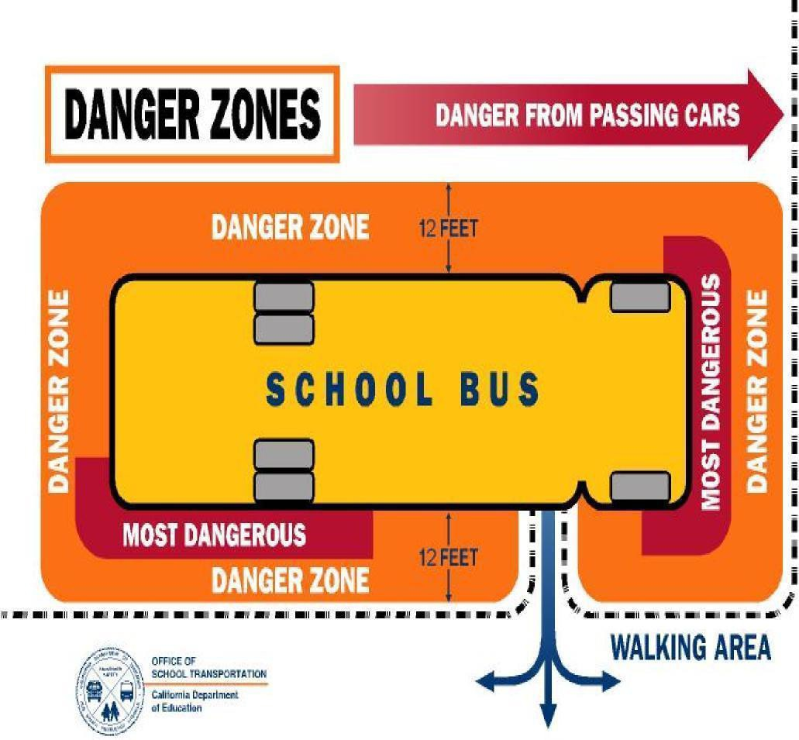

General Procedures of the School Bus

Students Transported in a School Bus Shall:
  - Be under the authority of, and responsible directly to, the driver of the school bus.
5 CCR 14103 (a) Pupils transported in a school bus or in a school pupil activity bus shall be under the authority of, and responsible directly to, the driver of the bus, and the driver shall be held responsible for the orderly conduct of the pupils while they are on the bus or being escorted across a street, highway or road. Continued disorderly conduct or persistent refusal to submit to the authority of the driver shall be sufficient reason for a pupil to be denied transportation. A bus driver shall not require any pupil to leave the bus reroute between home and school or other destinations.

Procedures for Boarding the Bus
Students should learn the correct bus route number they are riding to school or home. Students should look for the bus number located to the left of doors to enter or exit the bus. The bus route number will remain the same; but drivers may change.

Students shall wait at designated bus stops and we recommend they arrive ten minutes before the bus is scheduled to arrive. Students waiting for the bus shall do so in a safe location waiting in a line forming away from the edge of the curb or roadway at least six feet apart.

Students will not run towards the bus when the bus is approaching.

Students will wait at least twelve (12) feet back from the edge of the curb or roadway.

Students will wait for the bus to come to a complete stop and will not approach the bus until the front door is opened.

Students will be seated in their assigned seat or follow the directions from the driver of the bus.

Students shall talk quietly, not stand up nor turn around in the seat, respect others and their property as well as the property of the school bus.

After the school bus is loaded the flashing red lights will be turned off and the traffic will be allowed to move again. It is not possible to activate the lights to stop traffic a second time. If parents/guardians or students are late to the bus stop, plan to take your student to school.

Procedures for Unloading the Bus at School or at Bus Stop
Students will remain seated until the bus comes to a complete stop and the bus door is opened. The bus is not considered stopped until the door opens. Students shall not stand on the bus while the bus is in motion.

Students will exit the bus one row at a time beginning with the front of the bus in an orderly manner in compliance with the driver's instructions.

When exiting the bus, all students need to be alert in the doorway and stepwell area. Take care that articles such as drawstrings or loose items hanging from backpacks or coats are not caught in the doors. If a student sees another student caught in the door, the student shall stop and tell the driver. Do not get off the bus until the other student has been set free. (Backpacks or other items should be hand carried on and off the bus.)

After exiting, students should walk away from the bus and not touch or lean against the bus. They are not to return to or run after the bus. There will be no horseplay at or near the bus.

Students shall not cross the street upon which the bus is parked without assistance from the driver. Parents/guardians should wait on the side of the street which the designated stop is located.

If students require parents/guardians to be present at pick up (Kindergarten through 2nd and Special Education students), the school bus will return the student to the student’s school if parent/guardian is not present at bus stop.
Stand in lines or a group facing traffic so you can see the bus approaching.

Conduct at a School Bus Loading Zone & Bus Stops
Stand back 12 feet from where the bus will stop. Do not approach the bus until the driver opens the bus door. When loading at a school, follow the directions of the driver and/or teacher on bus duty. Remember, there may be several buses to watch out for, not just your own.
Never go under any bus to retrieve something you've dropped. Ask the driver to assist. Never run to a bus, always walk.
Destroying property, playing in or running across the street or any type of horseplay at a bus stop is
dangerous and prohibited.
When the bus is stopped to load or unload, the students are the direct responsibility of the bus driver and the driver’s directions must be followed.
When waiting for the bus in a car, be sure your car is not parked in the bus loading/unloading zone. Make sure that you are out of the car, waiting at the stop, prior to the bus arriving.

Procedures for Exiting the Bus at Escorted Stops
Palm Springs Unified School District requires all school bus drivers to cross all students, kindergarten through 8th grade, who need to go across the street as they depart the bus.

Always let your bus driver be the first person off the bus. The driver needs to activate the "red lights" that flash on the outside of the bus to warn cars to stop for children crossing the street.

Students will be given instructions to wait at an area designated by the driver.

Prior to unloading all students are to ensure that all personal items are safely stored in their backpack allowing their hands free for departure.

When escorting students, the driver shall, before opening the door, ensure that the flashing red light signal system and stop signal arm (if equipped) are activated and it is safe to exit the bus.

Once your driver is off the bus, you can walk down the bus steps, and wait for your bus driver to direct you to cross the street. Never go out into the street without the bus driver telling you to do so!

The driver will exit the bus and walk approximately 10 feet in front of the bus before turning to enter the roadway and instruct the students to “wait”.

Using the handheld stop sign, the driver will walk to the center of the street and assure all traffic is stopped before verbally signaling the students to walk between the bus and the driver. The driver shall escort the students across the street in front of the bus and follow the last student onto the bus, making sure that all students are seated.

Always walk between the bus and the bus driver, as you cross the street. Once you are on the other side of the street, stay on that side of the street. Do not play in the street. Go directly home.

Bus Seating Assignments
- In order to achieve the best student behavior on the buses and have consistent district-wide expectations for all student passengers, we have established the procedure of assigned seating for all students.

- Bus drivers will determine where students will sit and document it on their seating chart.

- All students shall be seated at least two to a seat; three when loads require it.

- The first student in a seat will move over against the window, seats will not be saved for other students or as directed by the bus driver.

Procedures for Bus Stop Changes
Students are only allowed to leave the bus at their regularly designated bus stop. Bus stops are designated based on student’s home of residence. Bus stops will normally only change when the student has moved to a different location. Maintaining the stop each student is assigned reduces the chance of a student getting lost or come up missing.

Walking to and From Bus Stop
Students should go directly home from the bus stop. Plan the safest route with the fewest streets to cross. If possible cross streets at the corners. Look in all directions before crossing and when safe walk across the street.

Watch for vehicles that might be making a turn while heading to and from a bus stop. Do not dart from between parked cars or shrubbery. Never accept a ride from a stranger.

If possible, face traffic when walking on roads without sidewalks and always use caution.

Be extra careful during times of sunrise and sunset, bad weather and during darkness (wear white clothing or something reflective). Leave home early enough so you don't have to run.

Rules and Regulations
All students (regular education and special education) are required to follow these safety rules:

- Arrive at the bus stop ten (10) minutes before the bus is scheduled to arrive.
- Use only his/her designated bus stop.
- Animals are not allowed on a school bus, except those students with a disability can be accompanied by a guide dog or service dog (Civil Code 54.2)
- Weapons, real or play; hazardous materials (i.e., matches or lighters) or other objects of a dangerous nature shall not be permitted on school buses.
- Respect the rights and property of others on the bus and at the bus stop.
- No fighting and rough play while at the bus stop, on the bus, or when getting on or off the bus. This violation may be a reason for immediate denial of bus transportation.
- Always enter and leave the bus through the entrance door except in emergencies or scheduled evacuation drills. Students shall not open emergency exits unless specifically instructed by the bus driver or emergency personnel.
- Remain quiet at railroad crossings.
- Keep all parts of the body inside the bus.
- Do not use profane language, obscene gestures, create excessive, or unnecessary noise.
- Do not throw objects while riding the bus.
- Help keep the bus safe & free from litter.
- No eating or drinking except those with special medical conditions requiring food or drink. No open containers of food and beverages are not allowed on the bus. Glass containers are not allowed on the school bus. Gum chewing will not be allowed on the bus.
- Students on a field trip that extends past normal mealtimes may be able to eat on the bus in the with the approval of the driver.
- Balls of any size shall be confined or contained in athletic bags or back packs. Balls should be in bags or backpacks at bus stops. (Hard balls and bats are not allowed except those fully enclosed in athletic bag.)
- Objects carried on the bus by students must be of a size that can easily be held on the student's lap. (Tennis rackets, baseball bats, scooters, bicycles and skateboards are not allowed except for charter trips.)
- Do not abuse or tamper with bus equipment (no writing on, cutting, or tearing of seats, etc.). Parent/guardians are responsible for damage done.
- Do not shout, scream, talk loudly, or make offensive remarks or gestures to other students, driver,
pedestrians, or motorists.
- Obey the request of the bus driver and give proper identification when requested.
- Always cross in front of the bus when it is necessary to cross the street.
- Do not consume any alcohol or use any vaping, cigarettes, matches, lighters while at bus stop or on the school bus.
- The use of cellular telephones or other electronic devices is limited to emergency situations to prevent disruption and maintain the safe operation of the school bus. The bus driver may direct the student to no longer use the device on the bus.
- Music players with headphones are permitted with the bus driver’s approval. Headphones shall be used at a volume low enough so that the students can hear any directions given by the driver.

Unauthorized Entry
Any person who enters a school bus or school pupil activity bus without prior authorization of the driver or other school official with intent to commit any crime and who refuses to disembark after being ordered to do so by the driver or other school official is guilty of a misdemeanor and is punishable by imprisonment in the county jail for not more than six months, by a fine of not more than one thousand dollars ($1,000), or by both. (Education Code 39842; 13 CCR 1256.5)

Audio/Video Camera Surveillance
Audio/Video cameras shall be used on school buses to monitor student behavior while traveling to and from school and school activities. Students found to be in violation of the bus conduct rules may be subject to discipline in accordance with District policy and regulations. The District may use both the audio and video recording capabilities of its recording equipment on school buses and such recording may be used in student discipline proceedings. The District believes the use of audio recordings will further enhance the safety of its students and staff.

The District Transportation Coordinator shall oversee the use and maintenance of the First Student’s bus surveillance system. Students and staff shall not tamper or interfere with video surveillance equipment on school buses. Persons found tampering with the bus surveillance system shall be subject to discipline and shall be responsible for the cost of any necessary repairs or replacement.

The District does utilize video and audio surveillance on all school buses and those video recordings may be used in student disciplinary proceedings. In addition, a prominent notice is posted in each bus, stating that the bus is equipped with a video monitoring system.

Video retained by First Student as part of an individual student’s disciplinary record shall be maintained and be made available to the District upon request.

The District will disclose video only as required by law; images of other students depicted in the video will be redacted to the greatest extent appropriate.

Outside of First Student management, only District staff will be permitted access to view surveillance videos. Information on video tapes will remain confidential.

Procedures for Discontinuance of Service Due to Reduced Visibility
- In order to ensure safe operations at all times, drivers will be responsible to assess road conditions on a continuous basis. If, due to atmospheric conditions, visibility on the roadway is reduced to 200 feet or less, the driver will advise the District Transportation Coordinator or designee of the fact and a decision will be made as to the next course of action.
- If the conditions warrant, whether or not students are aboard, the driver will remain parked and secure until it is safe to proceed on the route. School sites and the Superintendent will be notified as soon as possible.
- If the morning or afternoon routes have not commenced, the buses will be held until it is safe to proceed on the route. School sites and the Superintendent will be notified as soon as possible and notifications to parents will be made as appropriate (as soon as possible).

- The following steps shall be taken when the driver makes the decision to discontinue service:
1. Find a safe location to pull the bus completely off the roadway and park.
  - Shut off ALL lighting systems.
  - Contact dispatch.
  - Once conditions clear up, proceed on the route with caution.

Emergency Equipment
Each school bus shall be equipped with a first aid kit, roadside warning devices, and at least one fire extinguisher located in the driver’s compartment which meets the standards specified by law. Each driver as a part of their required daily vehicle inspection (pre-trip) shall ensure that the bus they are operating is properly equipped with the required emergency equipment based upon bus type/size and is in good working order. The fire extinguisher(s) are properly rated as required by law.

Incidents/Collisions on the School Bus
The District Transportation Coordinator along with the First Student Location Manager shall review all investigations of bus incidents and collisions to develop preventative measures. The Transportation Coordinator shall be notified of all bus incidents and collisions as required. In the event of an accident with students on board the bus, no student can be released from the bus until the CHP Officer releases them even if a parent is present. The only exception would be in the event the student needs medical attention.

Procedure for Reporting Bus Incidents/Collisions
In the event of a bus incident/collision, the driver shall immediately secure the bus and cause the appropriate authorities to be notified of the event. In all cases, regardless of the qualifying criteria for determining a school bus collision, the driver will provide a collision report to facilitate the reporting requirements for the Transportation Manager and/or designee(s).

Bus Safety and Evacuation Instruction
In accordance with all students who are transported in a school bus shall receive instruction in school bus emergency procedures and passenger safety from the First Student bus drivers. Prior to departure on field trips, the driver shall give safety instructions which include the location of emergency exits and the location and use of emergency equipment. Education Code 39831.5 (a) All pupils in prekindergarten, kindergarten, and grades 1 to 12, inclusive, in public or private school who are transported in a school bus or school pupil activity bus shall receive instruction in school bus emergency procedures and passenger safety. The county superintendent of schools, superintendent of the school district, or owner/operator of a private school, as applicable, shall ensure that the instruction is provided.

Passenger Restraint Systems
All school buses are equipped with a passenger restraint system. All passengers shall be required to be wear seatbelts while the bus is in motion. Bus drivers shall be informed of procedures to be followed to reasonably ensure that all passengers are secured. Title 5 CCR Section 14105: "All passengers in a school bus or in a school pupil activity bus that is equipped with passenger restraint systems in accordance with sections 27316 and 27316.5 of the Vehicle Code shall use the passenger restraint system...”)

The driver shall ensure that all students who board the bus are properly restrained. Instruction shall be given during the annual emergency evacuation drills on the proper use of the passenger restraint system while the bus is in motion. Prior to operation all drivers shall inspect as part of the pre-trip inspection the passenger restraint system currently available on each bus to ensure that all students are protected to the maximum extent. VC 27316 (c): "No person, school district, or organization with respect to a school bus equipped with passenger restraint systems pursuant to this section, may be charged for a violation of this code or any regulation adopted there under requiring a passenger to use a passenger restraint system, if a passenger on the school bus fails to use or improperly uses the passenger restraint system..." district or company policies and procedures should be developed to enforce disciplinary actions for non-use or improper use of the passenger restraint system. The driver, school district, or organization still may be charged civilly if reasonable care was not provided for the passenger(s).

School Bus Safety Law SB 1072
School bus drivers shall ensure that students are not left unattended on a school bus, except to perform red light escorts to other students 22112(d) VC. All drivers shall remain in the immediate vicinity of the school bus. Each school bus shall be equipped with an operational child safety alert system. A “child safety alert system” is a device located at the interior rear of a vehicle that requires the driver to either manually contact or scan the device before exiting the vehicle, thereby prompting the driver to inspect the entirety of the interior of the vehicle before exiting. School bus drivers shall at the conclusion of each run/route/trip perform a “student check” and post trip inspection. The driver shall walk to the rear of the bus checking each seat for sleeping children and personal items left behind by the students on their route. The driver will then activate the child check system at the rear of the bus and check all seats again as they walk back to the front of the bus. This is pursuant to Senate Bill 1072 which amends Education Code 39831.3(a) which requires the preparation of this Transportation Safety Plan.

School Bus Safety Violation Notification
California Education Code 39843 requires a school district to complete and submit form DL 1072 School Bus Safety Violation Notification if a driver is found negligent of leaving a child unattended aboard a school bus.
Reasons may include:
- Driver left a student unattended aboard a School bus, School Pupil Activity Bus, or Youth Bus and left the immediate vicinity of the vehicle.
- A disciplinary action was ordered and upheld in compliance with disciplinary procedures granted by law or collective bargaining agreement.
- A finding was made that the action constituted gross negligence.

Due Process
First Student provides each driver annual training and ongoing guidance specific to “child check” rules and regulations. It is the driver’s responsibility to conduct a child check procedure on their bus at the conclusion of their last stop. A driver returning to the terminal with a child on board, neglecting to do a child check, and/or leaving the immediate vicinity of the school bus with a child on board will be documented. First Student must submit the disciplinary actions taken and state the severity of the action by the school bus driver with notification to the District Transportation Coordinator. Depending on the severity of the situation one of the following actions may be taken:

  - A written reprimand by supervisor, and additional training specific to Child Check procedures.
  - Possible termination to serve with the Palm Springs Unified School District as recommended by the California Department of Education and Department of Motor Vehicles.
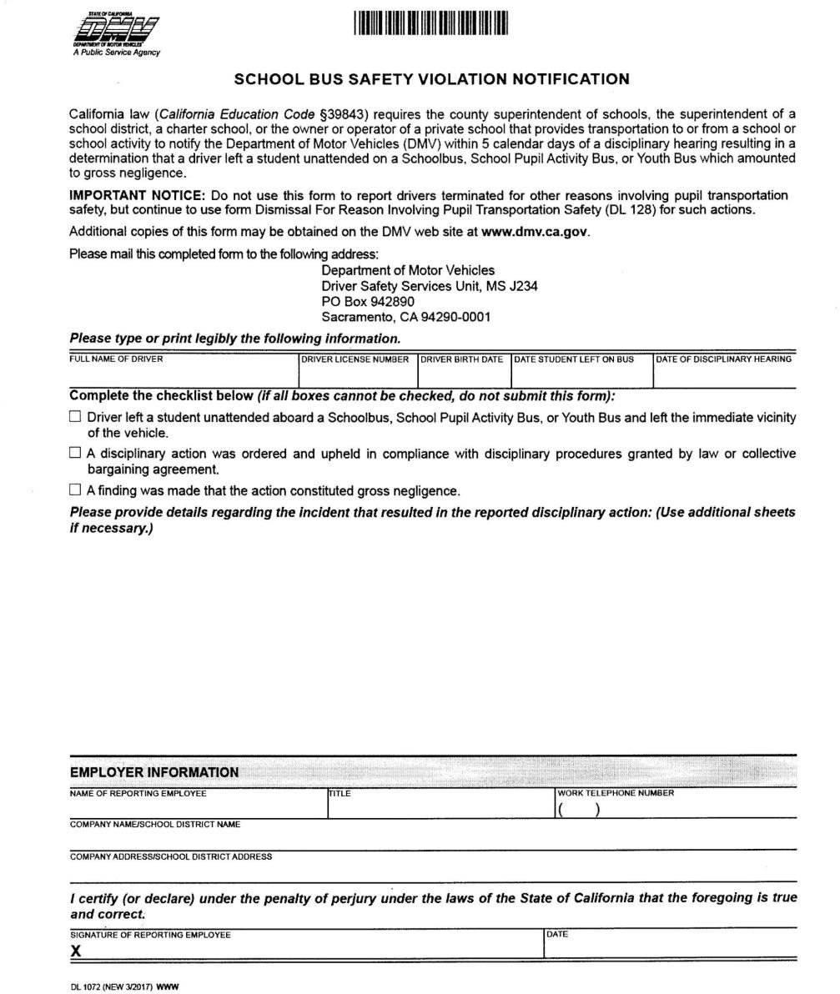

Mechanical Breakdown
When a school bus is disabled due to a mechanical failure and students are aboard that require transportation, the relief vehicle should drive to the front of and pull in line with and as close to the disabled vehicle as possible. The drivers of both vehicles should activate the hazard lights prior to the unloading and loading of passengers. Vehicle Code Section 22112(d) (2) Where the school bus is disabled due to mechanical breakdown. The driver of a relief bus that arrives at the scene to transport pupils from the disabled school bus shall not activate the amber warning light system, the flashing red light system, and stop signal arm.

Discipline Process
The below sequence of disciplinary actions is a guideline for District Transportation Coordinator, First Student Location Manager and Bus Drivers. Steps may be skipped if the offense is of a serious or dangerous nature. A first offense may result in immediate loss of riding privileges. The School Site Administrator and district transportation department personnel will consult and make a determination on how to proceed. Violation of any of the bus rules will result in the following sequence of actions

- Verbal warning given by the bus driver.

- Assigned seating by the bus driver.

- 1st School Bus Behavior Report must be completed with copies to School Site Administrator and District Transportation Coordinator.

- 2nd School Bus Behavior Report must be completed with copies to School Site Administrator and District Transportation Coordinator. A final determination of action will be made by the School Site Administrator.

Loading Activity/Field Trips at a School Site

Activity Field Trips

- The driver shall not activate the flashing amber warning light system when loading/unloading.

- The group or athletic team will assemble in an area away from the school bus. When the students are ready to load, the driver will commence loading.
- Upon completion of loading, the driver will proceed with the bus evacuation and safety presentation. This shall include an explanation and demonstration of all emergency exits, first aid kits, fire extinguishers, etc.

- Upon completion of the presentation, the driver will require the chaperone/coach to sign the trip sheet. The driver will then depart when safe to do so.

Loading/Unloading at the Activity/Field Trip Destination Site
Upon arrival at the destination, the driver will select an area where the bus can be lawfully parked and loading/unloading students can be reasonably controlled. The driver will provide instructions to the chaperone/coach(s) regarding the time and location where the group will assemble to reload the school bus.

Video cameras shall be used on school buses to monitor student behavior while traveling to and from school and school activities. Students found to be in violation of the district's bus conduct rules shall be subject to discipline in accordance with district policy and regulations.

All bus rules apply to field trips as they do on daily home to school routes.

Teachers shall provide a list of all passengers (students and adults) to driver prior to departure.

Additional Safety Rules for Activity/Field Trips:
All back packs, food etc. must be stored in the luggage bay under the bus. If food is authorized, it shall be kept in an ice chest to prevent food borne illness. Exceptions shall be pre-authorized by administration. A driver may exercise individual judgment in dealing with the specific needs of a student who is ill or experiencing motion sickness to serve the individual needs of the student.

Music players with headphones are permitted. Headphones shall be used at a volume low enough so that the students can hear any directions given by the driver. DVD/video players are not allowed. No flash photography is permitted on the bus.

Persistent refusal to follow the rules is sufficient cause for the driver to cancel the trip and return to school. Students attending a field trip are expected to ride the bus for the full trip. Parents/guardians wishing to transport their student’s home from a field trip must give an advanced written request and sign the student out of the field trip through teacher in charge. Only students who are members of the class taking the field trip shall be allowed to attend.

Teacher/Chaperone Responsibilities Aboard Bus
Students transported in a school bus shall be under the authority of and responsible directly to the driver of the bus and the driver shall be held responsible for the orderly conduct of the students while they are on the bus. Chaperones/coaches shall assist the bus driver to maintain a safe environment. Continued disorderly conduct or persistent refusal to submit to the authority of the driver shall be sufficient reason for a student to be denied transportation. 5 CCR 14103 (a) (a) Pupils transported in a school bus or in a school pupil activity bus shall be under the authority of, and responsible directly to, the driver of the bus, and the driver shall be held responsible for the orderly conduct of the pupils while they are on the bus or being escorted across a street, highway or road. Continued disorderly conduct or persistent refusal to submit to the authority of the driver shall be sufficient reason for a pupil to be denied transportation. A bus driver shall not require any pupil to leave the bus in route between home and school or other destinations. Chaperones may not take other children with them on the field trip, including preschool children, infants, and students enrolled in another class. Chaperones must follow all school and district rules. The teacher is in charge of the trip and the bus driver is in charge of the bus. All bus rules must be followed by chaperones and students. The minimum age of a chaperone is 21. There is to be no smoking or alcoholic beverage use on the field trip. Appropriate language is to be used by everyone.

Required Vehicle Information on Activity/Field Trips
A vehicle shall not be put in motion until all passengers are seated. All passengers must remain seated at all times while the vehicle is in motion. Exemptions: The provision does not apply to adults acting upon a request by a school bus driver to supervise or assist a student. 13 CCR 1217(e) and It shall be the responsibility of the teacher/chaperone to assist the driver in ensuring that the rules are enforced. The driver shall meet prior to the trip with teachers and chaperones to review safety rules and teacher/chaperone expectations. At least one teacher shall be seated at the rear emergency exit to facilitate emergency evacuation and to help maintain discipline in the back of the bus.
Prior to departure on all school activity trips, all students on the school bus shall receive safety instruction which include the following:
  - Location of emergency exits.
  - Location & use of emergency equipment.
  - Instruction on responsibilities of passengers seated next to an emergency exit.
  - Instruction in proper passenger behavior.

The following field trip data shall be documented and retained at First Student:
- Name of school/event site
- Location of school/event site
- Departure date and return dates of trip
- Name of supervising adults
- Subjects covered in safety instruction
- Time of instruction scheduled and actual departure, arrival, and return time to school.
- Bus driver's name.
- School bus number.
- Additional remarks/comments.
Employees of the district and parent/guardian of students of the district may ride district school buses to and from educational activities authorized by the district subject to available space.

Special Education Transportation Guidelines

What Special Needs Equipment Might Be Transported on a School Bus?
The following criteria is followed when transporting a Special Education student with special needs. Special equipment that may be transported are wheelchairs, walkers, crutches, child safety-seats (car seat), harnesses, d-rings and star-seats. Other equipment that may be required such as oxygen, battery packs, medical equipment and service animals.

Medical/Health Issues
As schools are serving more students with disabilities who have severe medical/health conditions, the transportation staff is finding it necessary to provide both routine and emergency health care to students during transportation. Additionally, transportation staff may be exposed to dangerous infectious or communicable diseases. Training regarding medical/health issues can reasonably be divided into two categories: precautionary handling, and care and intervention will be provided annually by District staff.

All transportation staff, including drivers, attendants/monitors, and dispatch staff, shall be trained in "universal precautions" relative to the handling and exposure to contagious and communicable diseases i.e. Covid-19.

Safe Transportation of Students in Wheelchairs or other Mobility Assistance Devices
- Whenever possible or feasible, minimize the liabilities and risks involved in transportation of wheelchair passengers by ensuring all proper procedures are followed.
- A person transported in this manner must be fitted with a dynamically tested occupant restraint (i.e., a lap/shoulder belt assembly or a child car seat).
- Wheelchairs may be transported but must be appropriately secured. When a student is transported in a wheelchair, a four-point tie down is required on the school buses. The wheelchair brakes must be operational in order to transport the student on a school bus.

- Forward facing wheelchair for a paraplegic student should have a head rest or proper head/neck support to prevent "whiplash" injuries.

- All lap belts must have an auto-type buckle, not Velcro-type fasteners and must be permanently attached to the wheelchair frame.

- By law and First Student policy, we will not transport a student in a collapsible wheelchair.

- School buses cannot transport lead acid batteries in the passenger compartment of any vehicle.

- Every wheelchair must be equipped with footrest and appropriate straps as needed. The wheelchair should be the appropriate size for the height and weight of the student. If questions arise, please consult with the physical therapist who serves the student.

Important Special Education Student’s Information Available to Transportation Staff to Ensure Safety of the Student They are Transporting
- Student pick-up/drop-off location (one location specified, or unlimited alternative locations allowed).
- Control and management of confidential information.
- When and how to involve emergency medical/law enforcement personnel.

Special Equipment Use and Operation
There is a wide variety of equipment to accommodate students with disabilities that is required to be part of the transportation vehicle's environment. It is necessary for the First Student transportation staff to be familiar with the design and operating procedure for this special equipment, as well as knowing how to conduct equipment inspection and make simple "field adjustments" during breakdowns. Some examples are:

- Power lifts or ramps.
- Emergency escape exits, including doors, windows and roof hatches.
- Required emergency equipment.
- Power cutoff switch.
- Emergency communications system(two-way radio).
- Air conditioning system (if applicable).
- Mobile seating device, including trays and accessories, securement system hardware and occupant securement system.
- Adaptive and assistive devices used to support or secure students, mobility aids, special belts, harnesses and devices (such as special crutches, braces, or wheelchairs, including assistive technology devices).

- All specially equipped school buses should be equipped with electronic voice communication systems. These may be provided and installed by the body manufacturer, distributor, school district, operator or other party.

- Service animals can be transported to assist a student with disabilities. District policies and procedures, as well as training, need to be established prior to transport.

- Any required special equipment provided by the First Student, district, school, parent or guardian shall accompany students with disabilities for transportation on the school bus.

Additional Instructions for Special Needs Students

- School bus drivers shall pick-up/drop-off at designated stops

- Loading and unloading at school sites will be conducted utilizing the same procedures as or home- to-school special need students who are must-be-met.

- The driver shall not activate the flashing red light system where a pupil requires physical assistance from the driver or authorized attendant to board or leave the school bus; providing the assistance extends the length of time the school bus is stopped beyond the time required to load or unload a pupil that does not require physical assistance.

- Special needs student accountability and observation includes mandatory reporting evidence of neglect or abuse.

Transportation Procedures for Foster Youth Students

When a child who is placed in foster care is enrolled in and attending a District school other than the school that is considered the child’s school of origin under applicable law, the child will be entitled to the same transportation arrangements and options as are available to other District students who are not in foster care, but who are otherwise similarly-situated. If District-provided transportation is available to the child, the District will promptly arrange for such transportation so that transportation does not hinder the child’s immediate enrollment. Applicable federal law requires school districts to develop procedures to ensure that children in foster
care who need transportation to their respective schools of origin promptly receive that transportation, and to ensure that such transportation is arranged and provided.

When the District is notified that a child in foster care who resides (or who will soon reside) in the District will be attending a school of origin that is located in another school district, the District’s designated point of contact for the education of children in foster care, or his/her designee, will participate in the transportation planning process for the child upon the request of a representative of a child welfare agency, a representative of the school of origin, or the child’s agency-designated foster caregiver, or where such participation is otherwise required by law.

Transportation Planning when the School of Origin is Located in the District

1. A representative of the relevant child welfare agency or the child’s agency-designated foster parent or adult caregiver should give clear notice to the District, as soon as practicable, that a child in foster care needs, or may need, transportation to a District school that is the child’s school of origin. Such notice may be given in writing or verbally directly to the District’s designated point of contact for the education of children in foster care, or in writing to the applicable building principal.

2. After the District receives notice of a new or pending foster care placement for which a District school would be considered the child’s school of origin and for which the child needs or may need transportation, the District will promptly begin the process of establishing an individualized transportation plan.

3. A transportation strategy for providing transportation to and from the school of origin on
school days, inclusive of identifying:
- the mode(s) or method(s) of transportation,
- the person or entity responsible for providing the transportation, and
- if applicable, the person or entity who is responsible for making any specific
arrangements that are necessary to the implementation of any method or mode of
transportation.

4. Identification of any transportation options that may be available to facilitate the child’s
participation in after-school and extracurricular activities as applicable to the child, and a
description of the District’s role, if any, in relation to providing or arranging such options;

5. If the child in foster care is a child with a disability, the District will evaluate any relevant
accommodations or specific transportation-related services that the child requires in relation to
his/her disability (e.g., as provided in the child’s Individualized Education Program (IEP)) and
determine how to coordinate transportation planning in light of any such other rights and
obligations.

6. To the extent permitted by applicable law, the child’s designated foster parent(s) or other
formally-designated caregiver may voluntarily agree to personally transport or otherwise
personally arrange for the child’s daily school-related transportation by exercising their lawful
authority (e.g., by making decisions under the “reasonable and prudent parent” standard). If
such a caregiver is willing to voluntarily provide or arrange for the child’s transportation in
whole or in part (e.g., on certain days) and does not currently desire District-provided or
District-arranged transportation on such school days, the plan may provide for documentation
that the child does not presently need District-provided or District-arranged transportation to
the extent applicable. At any time, the caregiver may inform the District and the child welfare
agency that he/she is no longer able to provide or arrange for the child’s school-related
transportation, and a new transportation plan will be promptly developed.

7. Transportation planning may attempt to maximize the existing District transportation system by exploring ways that the child can be transported to a location on an existing bus route that
serves the school of origin. This includes locations for which minor route adjustments can be
made without adding appreciable cost or adversely affecting the operational function of the
route (e.g., route timing). When transportation cannot be accommodated by the existing District transportation system, and outside transportation contractor will be used to provide this service.

8. Multiple factors were considered and addressed when determining transportation options for foster care students, including: safety for the student and other students being transported; student age; length of commute; and distance. Transportation planning may use or leverage other existing intra-district transportation options that allow children to be transported within the District, examples of which may include:

- any transportation options that may be offered to students who are attending a school outside of their normal attendance area;
- any transportation options that permit students to be picked up or dropped off at locations other than their residence (e.g., at child-care providers);
- transportation options already being used for students who are homeless, and other vehicles that are used to transport children receiving special education services.

Requesting of Transportation Services

Education Services will send a request to the Transportation Department with the students name and school location that he/she will be attending. Once that is received, we will review all current bus routes the District has to determine if we can adjust the route to add the student. In the event the system cannot accommodate the request, we will contract with an outside vendor for transportation services. The guidelines for transportation requirements throughout this transportation plan are the same even when the District elects to utilize an outside contractor to provide these services.

Once a route has been determined, the Foster Care parents or guardians will be given all the pickup and drop information for the student. The transportation plan for the student will continue as long as the student is assigned to their school.

